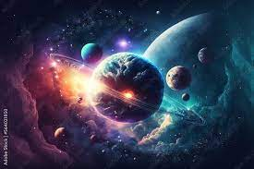

For fonts: sans-serif

AI in Space:

1. "AI Helping Astronauts: How artificial intelligence assists astronauts in space missions.",
2. "AI in Space Exploration: The use of smart computers to explore and study space.",
3. "Smart Robots in Space: How intelligent robots help with tasks in outer space.",
4. "AI Space Navigation: How computers guide spacecraft safely through the cosmos.",
5. "Space Computers: AI's Role: How computers with brains help us explore the stars.",
6. "AI Discovering New Planets: How artificial intelligence helps find planets beyond our solar system.",
7. "AI and Telescopes: How smart technology improves space telescopes.",
8. "AI's Space Insights: How computers give us new knowledge about the universe.",
9. "Robots in Space: The AI Connection: How robots and computers team up for space missions.",
10. "AI and Space Research: How computers aid scientists in studying space."